CENWP-OD-B 27 June 2023

MEMORANDUM FOR THE RECORD

SUBJECT: 23BON040 MFR CI Pond Lamprey Mortality

On 27 June, Bonneville Fisheries discovered one Pacific Lamprey mortality in the pond near FV5-4 of the Cascade Island Lamprey Passage System. The fish was scanned for PIT tags, inspected, and returned to the river.

- Species – Pacific Lamprey (Entosphenus tridentatus)
- Origin – Unknown
- Length – 36.2 cm
- Marks and tags – None
- Marks and Injuries found on carcass – None
- Cause and Time of Death – Unknown
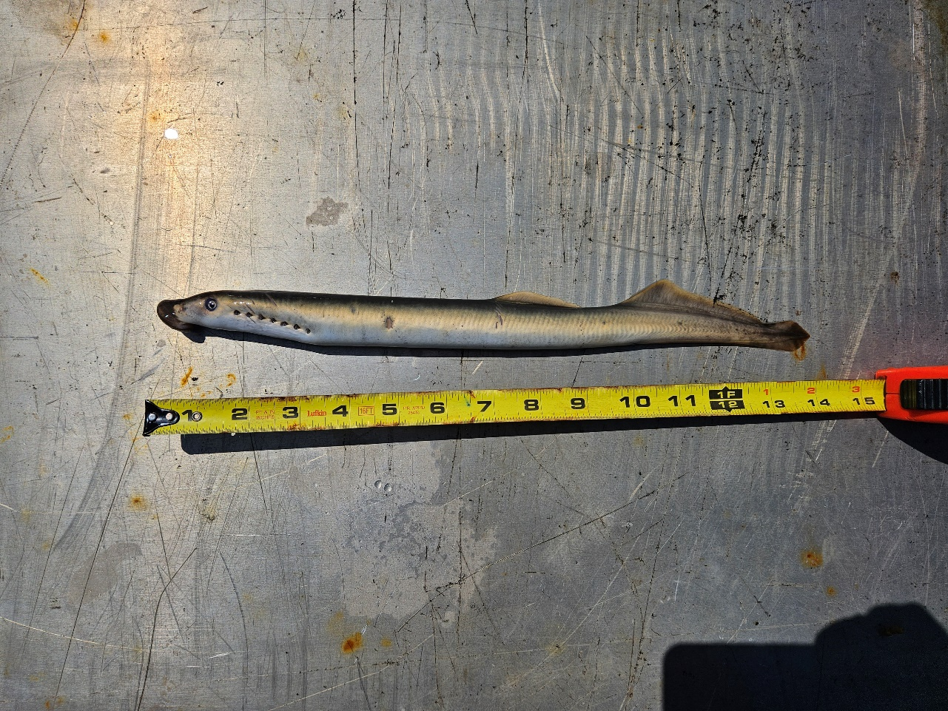
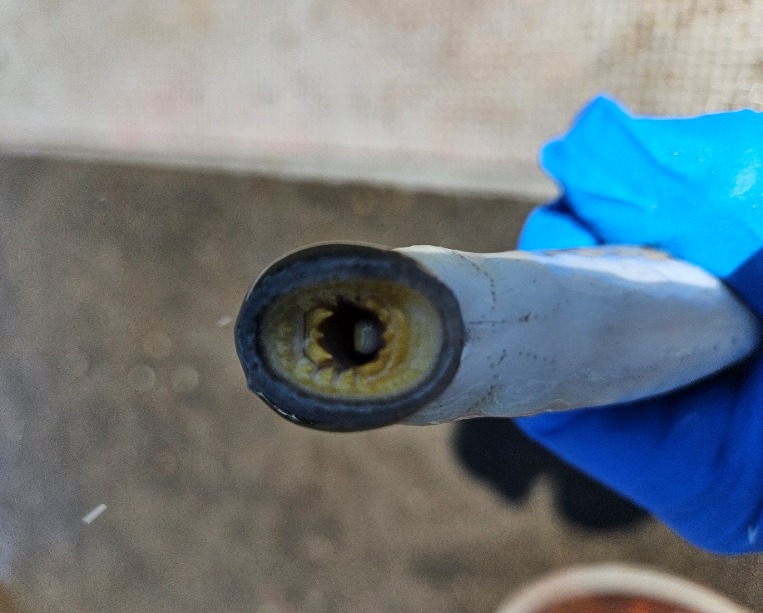
- Future and Preventative Measures – None

Sincerely,
Bonneville Project Fisheries

